Aaron Andal
17.04.22- M07 Xarxes

Activitat 2.3. Enrutament complex
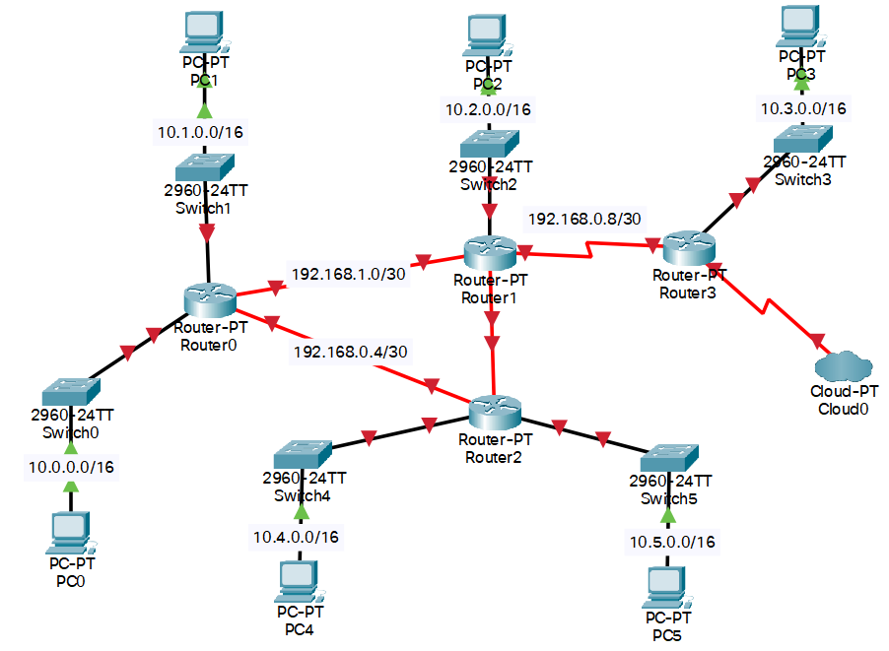

- Una taula resum de les adreces IP assignades a cada interfície de cadascun dels routers (Router / Interfície / Adreça IP)

Dispositiu | Interfície | Adreça IP
PC 0 | FastEthernet0 | 10.0.0.2/16
R0 | FastEthernet0/0 | 10.0.0.1/16
R0 | FastEthernet1/0 | 10.1.0.1/16
R0 | FastEthernet5/0 | 192.168.1.1/30
R0 | FastEthernet4/0 | 192.168.0.5/30
PC 1 | FastEthernet0 | 10.1.0.2/16
R1 | FastEthernet0/0 | 10.2.0.1/16
R1 | FastEthernet4/0 | 192.168.1.2/30
R1 | FastEthernet5/0
R1 | Serial0/2/0 | 192.168.0.9/30
PC 2 | FastEthernet0 | 10.2.0.2/16
R2 | FastEthernet0/0 | 10.4.0.1/16
R2 | FastEthernet1/0 | 10.5.0.1/16
R2 | FastEthernet4/0 | 192.168.0.6/30
R2 | FastEthernet5/0
PC 3 | FastEthernet0 | 10.0.0.2/16
R3 | FastEthernet0/0 | 10.3.0.2/16
R3 | Serial0/3/0 (Cloud)
R3 | Serial0/2/0 | 192.168.0.10/30
PC 4 | FastEthernet0 | 10.4.0.2/16
PC 5 | FastEthernet0 | 10.5.0.2/16

- Una taula resum de les taules d’enrutament de cadascun dels routers (Router / AX / MX / IPHOP)

Routing estátic

La pregunta és la mateixa:

Per anar a la Xarxa X hem de pasar per la Interfície Serial X. S’ha de fer també la tornada. Es crea un Túnel VPN.

Router | Per anar a la AX | Amb MX | Surts per IPHop
R0 | 10.2.0.0/16 | 255.255.0.0 | 192.168.1.2
 | 10.3.0.0/16 | 255.255.0.0 | 192.168.1.2
 | 10.4.0.0/16 | 255.255.0.0 | 192.168.0.6
 | 10.5.0.0/16 | 255.255.0.0 | 192.168.0.6
R1 | 10.1.0.0/16 | 255.255.0.0 | 192.168.1.1
 | 10.0.0.0/16 | 255.255.0.0 | 192.168.1.1
 | 10.4.0.0/16 | 255.255.0.0 | 192.168.1.1
 | 10.5.0.0/16 | 255.255.0.0 | 192.168.1.1
 | 10.3.0.0/16 | 255.255.0.0 | 192.168.0.10
R2 | 10.0.0.0/16 | 255.255.0.0 | 192.168.0.5
 | 10.1.0.0/16 | 255.255.0.0 | 192.168.0.5
 | 10.2.0.0/16 | 255.255.0.0 | 192.168.0.5
 | 10.3.0.0/16 | 255.255.0.0 | 192.168.0.5
R3 | 10.5.0.0/16 | 255.255.0.0 | 192.168.0.9
 | 10.4.0.0/16 | 255.255.0.0 | 192.168.0.9
 | 10.0.0.0/16 | 255.255.0.0 | 192.168.0.9
 | 10.1.0.0/16 | 255.255.0.0 | 192.168.0.9
 | 10.2.0.0/16 | 255.255.0.0 | 192.168.0.9

R0:
R0(config)#ip route 10.2.0.0 255.255.0.0 192.168.1.2
R0(config)#ip route 10.3.0.0 255.255.0.0 192.168.1.2
R0(config)#ip route 10.4.0.0 255.255.0.0 192.168.0.6
R0(config)#ip route 10.5.0.0 255.255.0.0 192.168.0.6

R1:
R1(config)#ip route 10.1.0.0 255.255.0.0 192.168.1.1
R1(config)#ip route 10.0.0.0 255.255.0.0 192.168.1.1
R1(config)#ip route 10.4.0.0 255.255.0.0 192.168.1.1
R1(config)#ip route 10.5.0.0 255.255.0.0 192.168.1.1
R1(config)#ip route 10.3.0.0 255.255.0.0 192.168.0.10

R2:
R2(config)#ip route 10.0.0.0 255.255.0.0 192.168.0.5
R2(config)#ip route 10.1.0.0 255.255.0.0 192.168.0.5
R2(config)#ip route 10.2.0.0 255.255.0.0 192.168.0.5
R2(config)#ip route 10.3.0.0 255.255.0.0 192.168.0.5

R3:
Router(config)#ip route 10.5.0.0 255.255.0.0 192.168.0.9
Router(config)#ip route 10.4.0.0 255.255.0.0 192.168.0.9
Router(config)#ip route 10.0.0.0 255.255.0.0 192.168.0.9
Router(config)#ip route 10.1.0.0 255.255.0.0 192.168.0.9
Router(config)#ip route 10.2.0.0 255.255.0.0 192.168.0.9

- Les comandes utilitzades per a configurar els routers

PC0 a la PC5: Com no tenim DHCP les configurem manualment les IP (Segons la taula definida abans) I li posem el GATEWAY corresponent (Segons la taula definida abans).

R0:
R0>enable
R0#
R0#configure terminal
Enter configuration commands, one per line. End with CNTL/Z.
R0(config)#interface FastEthernet0/0
R0(config-if)#ip address 10.0.0.1 255.255.0.0
R0(config-if)#no shutdown
R0(config-if)#
%LINK-5-CHANGED: Interface FastEthernet0/0, changed state to up

%LINEPROTO-5-UPDOWN: Line protocol on Interface FastEthernet0/0, changed state to up

R0(config-if)#exit
R0(config)#interface FastEthernet1/0
R0(config-if)#ip address 10.1.0.1 255.255.0.0
R0(config-if)#no shutdown
R0(config-if)#
%LINK-5-CHANGED: Interface FastEthernet1/0, changed state to up

%LINEPROTO-5-UPDOWN: Line protocol on Interface FastEthernet1/0, changed state to up

R0(config-if)#end
R0#copy running-config startup-config
Destination filename [startup-config]?
Building configuration...
[OK]
R0#
%SYS-5-CONFIG_I: Configured from console by console

R0#
R0#configure terminal
Enter configuration commands, one per line. End with CNTL/Z.
R0(config)#interface FastEthernet5/0
R0(config-if)#ip address 192.168.1.1 255.255.255.252
R0(config-if)#no shutdown
R0(config-if)#
R0(config-if)#exit
R0(config)#interface FastEthernet4/0
R0(config-if)#ip address 192.168.0.5 255.255.255.252
R0(config-if)#no shutdown
R0(config-if)#
%LINK-5-CHANGED: Interface FastEthernet4/0, changed state to up

%LINEPROTO-5-UPDOWN: Line protocol on Interface FastEthernet4/0, changed state to up

R0(config-if)#end
R0#copy running-config startup-config
Destination filename [startup-config]?
Building configuration...
[OK]
R0#
%SYS-5-CONFIG_I: Configured from console by console

R2
R2>enable
R2#conf
R2#configure ter
R2#configure terminal
Enter configuration commands, one per line. End with CNTL/Z.
R2(config)#inter
R2(config)#interface Fa
R2(config)#interface FastEthernet 0/0
R2(config-if)#ip address 10.4.0.1 255.255.0.0
R2(config-if)#no shutdown

R2(config-if)#
%LINK-5-CHANGED: Interface FastEthernet0/0, changed state to up

%LINEPROTO-5-UPDOWN: Line protocol on Interface FastEthernet0/0, changed state to up
exit
R2(config)#interface Fa1/0
R2(config-if)#ip address 10.5.0.1 255.255.0.0
R2(config-if)#no shutdown

R2(config-if)#
%LINK-5-CHANGED: Interface FastEthernet1/0, changed state to up

%LINEPROTO-5-UPDOWN: Line protocol on Interface FastEthernet1/0, changed state to up

R2(config-if)#end
R2#
%SYS-5-CONFIG_I: Configured from console by console

R2#copy running-conf
R2#copy running-config start
R2#copy running-config startup-config
Destination filename [startup-config]?
Building configuration...
[OK]
R2#

R2#
R2#configure terminal
Enter configuration commands, one per line. End with CNTL/Z.
R2(config)#interface FastEthernet4/0
R2(config-if)#ip address 192.168.0.6 255.255.255.252
R2(config-if)#no shutdown
R2(config-if)#
%LINK-5-CHANGED: Interface FastEthernet4/0, changed state to up

%LINEPROTO-5-UPDOWN: Line protocol on Interface FastEthernet4/0, changed state to up

R2#copy running-conf
R2#copy running-config start
R2#copy running-config startup-config
Destination filename [startup-config]?
Building configuration...
[OK]
R2#

R1:
R1>enable
R1#
R1#configure terminal
Enter configuration commands, one per line. End with CNTL/Z.
R1(config)#interface FastEthernet0/0
R1(config-if)#ip address 10.2.0.1 255.255.0.0
R1(config-if)#no shutdown
R1(config-if)#
%LINK-5-CHANGED: Interface FastEthernet0/0, changed state to up

%LINEPROTO-5-UPDOWN: Line protocol on Interface FastEthernet0/0, changed state to up

R1(config-if)#exit
R1(config)#interface FastEthernet4/0
R1(config-if)#ip address 192.168.1.2 255.255.255.252
R1(config-if)#no shutdown
R1(config-if)#
%LINK-5-CHANGED: Interface FastEthernet4/0, changed state to up

%LINEPROTO-5-UPDOWN: Line protocol on Interface FastEthernet4/0, changed state to up

R1(config-if)#exit
R1(config)#interface Serial2/0
R1(config-if)#ip address 192.168.0.9 255.255.255.252
R1(config-if)#no shutdown
R1(config-if)#

R3:
Router>enable
Router#
Router#configure terminal
Enter configuration commands, one per line. End with CNTL/Z.
Router(config)#interface FastEthernet0/0
Router(config-if)#ip address 10.3.0.1 255.255.0.0
Router(config-if)#no shutdown
Router(config-if)#
%LINK-5-CHANGED: Interface FastEthernet0/0, changed state to up

%LINEPROTO-5-UPDOWN: Line protocol on Interface FastEthernet0/0, changed state to up
Router(config-if)#
Router(config-if)#exit
Router(config)#interface Serial2/0
Router(config-if)#ip address 192.168.0.10 255.255.255.252
Router(config-if)#no shutdown
Router(config-if)#
%LINK-5-CHANGED: Interface Serial2/0, changed state to up

Router(config-if)#end
Router#copy running-config startup-config
Destination filename [startup-config]?
Building configuration...
[OK]
Router#
%SYS-5-CONFIG_I: Configured from console by console

%LINEPROTO-5-UPDOWN: Line protocol on Interface Serial2/0, changed state to up

4. Les comandes utilitzades per comprovar la connectivitat correcta de tota la xarxa

a) Un ping del PC3 al PC5

Cisco Packet Tracer PC Command Line 1.0
C:\>ping 10.5.0.2

Pinging 10.5.0.2 with 32 bytes of data:

Request timed out.
Request timed out.
Request timed out.
Reply from 10.5.0.2: bytes=32 time=4ms TTL=124

Ping statistics for 10.5.0.2:
Packets: Sent = 4, Received = 1, Lost = 3 (75% loss),
Approximate round trip times in milli-seconds:
Minimum = 4ms, Maximum = 4ms, Average = 4ms

C:\>ping 10.5.0.2

Pinging 10.5.0.2 with 32 bytes of data:

Reply from 10.5.0.2: bytes=32 time=9ms TTL=124
Reply from 10.5.0.2: bytes=32 time=23ms TTL=124
Reply from 10.5.0.2: bytes=32 time=6ms TTL=124
Reply from 10.5.0.2: bytes=32 time=4ms TTL=124

Ping statistics for 10.5.0.2:
Packets: Sent = 4, Received = 4, Lost = 0 (0% loss),
Approximate round trip times in milli-seconds:
Minimum = 4ms, Maximum = 23ms, Average = 10ms

C:\>

b) Un traceroute I ping del PC3 al PC0

C:\>tracert 10.0.0.2

Tracing route to 10.0.0.2 over a maximum of 30 hops:

1 0 ms 0 ms 0 ms 10.3.0.1
2 0 ms 7 ms 0 ms 192.168.0.9
3 0 ms 13 ms 9 ms 192.168.1.1
4 * 2 ms 0 ms 10.0.0.2

Trace complete.

C:\>
C:\>ping 10.0.0.2

Pinging 10.0.0.2 with 32 bytes of data:

Reply from 10.0.0.2: bytes=32 time=7ms TTL=125
Reply from 10.0.0.2: bytes=32 time=10ms TTL=125
Reply from 10.0.0.2: bytes=32 time=4ms TTL=125
Reply from 10.0.0.2: bytes=32 time=4ms TTL=125

Ping statistics for 10.0.0.2:
Packets: Sent = 4, Received = 4, Lost = 0 (0% loss),
Approximate round trip times in milli-seconds:
Minimum = 4ms, Maximum = 10ms, Average = 6ms

C:\>
b) Un traceroute I ping del PC5 al PC2
Cisco Packet Tracer PC Command Line 1.0
C:\>ping 10.2.0.2

Pinging 10.2.0.2 with 32 bytes of data:

Request timed out.
Reply from 10.2.0.2: bytes=32 time<1ms TTL=125
Reply from 10.2.0.2: bytes=32 time<1ms TTL=125
Reply from 10.2.0.2: bytes=32 time<1ms TTL=125

Ping statistics for 10.2.0.2:
Packets: Sent = 4, Received = 3, Lost = 1 (25% loss),
Approximate round trip times in milli-seconds:
Minimum = 0ms, Maximum = 0ms, Average = 0ms

C:\>tracert 10.2.0.2

Tracing route to 10.2.0.2 over a maximum of 30 hops:

1 0 ms 0 ms 0 ms 10.5.0.1
2 0 ms 0 ms 0 ms 192.168.0.5
3 0 ms 0 ms 0 ms 192.168.1.2
4 0 ms 0 ms 0 ms 10.2.0.2

Trace complete.

C:\>

